HELIDECK
INSPECTION REPORT
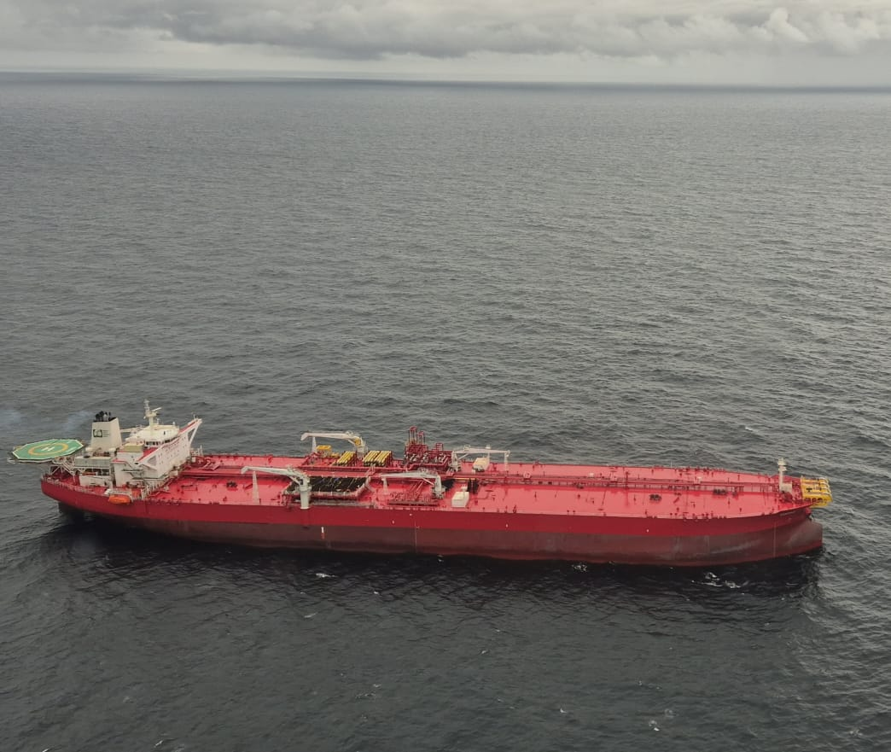

Landing site Name | FSO TOPAZ
Owner/Operator | WORLD CARRIER SHIPMENT
Inspector(s) | OLISA KENECHUKWU
Operational Clearance (Day/Night) | DAY, NIGHT-MEDIVAC
D Value  T Value | 21  12.8
Date of Previous Inspection | NIL
Date of Current Inspection | 27TH July, 2026
Date of Next Inspection | 26TH July, 2026

This report template and the contents herein are based on the provisions of UK CAA CAP 437 and the Nigerian NCAA NCARS

INSTALLATION DETAILS
Item | Comments
Installation Type  Platform / FPSO / Semi-Sub /  Seismic / NUI / MOPU / Lay Barge / Crane Barge / Support  Vessel / Jack up / Other | FSO
Location of Inspection | EBOK FIELD
Area of operations | EBOK
Owners Name | ORIENTAL ENERGY RESOURCES
Owners Address
Name of contact
Job Position
Phone
E-mail
Helideck drawings – (a list of details which should be included at the end of this section) Drawing number:  Date:  Do the plans accurately show the detail that is required? If no, state omissions. | 1562-100-A-005  19th June 2026  YES
Helideck Height
AMSL (feet)
Installation / Vessel identification  Location of name (on all sides) of vessel  Clearly visible  Illumination | COMPLIANT

OFFSHORE HELIDECK INSPECTION CHECKLIST
Manuals  UK CAA CAP 437  Helicopter Procedures Manual detailing:  - Normal duties  - Emergency response  - Training  - Refueling  Dangerous Goods  ICAO/IATA DG Regulations  Passenger Safety Briefing for aircraft type being used | NOT SIGHTED  NOT COMPLIANT

HELIDECK SURFACE
Item | Comment
Colour: (If light grey or aluminum markings should be highlighted):  Condition: (Good, fair, or poor):  Cleanliness: (Good, fair, or poor):  Level: | GREEN AND ALUMINIUM  GOOD  GOOD
Nonslip characteristics (estimated): High/Medium/Low/Nil: | HIGH
Last friction test:  Date:  Validity: one (1) year only  For Exceptions: State Tested by whom:  if less than 0.5mu, nets should be retained | APRIL 2026
Gutter or raised curb? Around the entire perimeter: | GUTTER
Drainage: (Guttering clean?): | CLEAN
Deck sealed? (Deck sealed, no holes in deck for leaking/burning fuel) | SEALED
Aircraft Tie-down points: 3m, 5m, 7m? | COMPLIANT

HELIDECK DIMENSIONS AND MARKINGS:
Item | Comment
Overall Helideck Draw or cut and past the design of the helideck. | 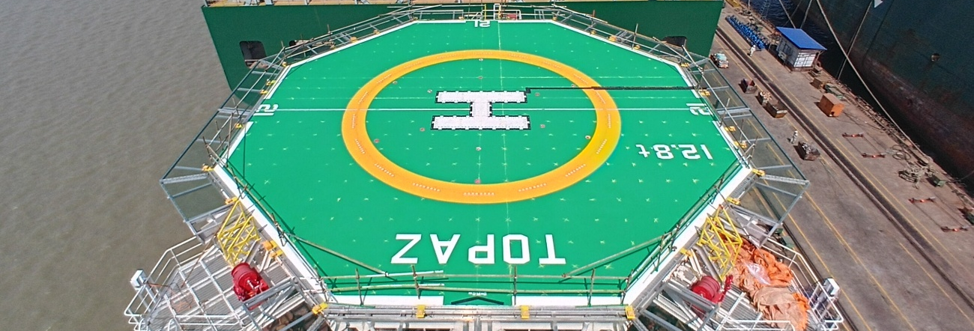
Overall Helideck Dimensions: Include run-off area if applicable: | 21D
Installation/rig/vessel name:  State name painted on deck and position. Minimum 1.2 meters (preferably 2 meters) | TOPAZ  COMPLIANT
Perimeter line: Should be white, 30cm wide. | COMPLIANT
Touchdown/Position Marking Circle:  It should be yellow, 1 meter wide. State inner diameter (0.5D). | COMPLIANT
Chevron:  Dimensions (0.79m x 0.10m), colour (black), angle (210º), location. | COMPLIANT
D value marking:  Correct value? Colour, height, location. | 21D  WHITE
"H":  State size, colour, location, Swung? (4 x 3 x 0.75m,) | WHITE  COMPLIANT
Max. Allowable Mass: Correct value, size & colour (0.9m, white),  Helideck integrity  Document Date: | 12.8  WHITE  29TH March 2026

HELICOPTER TYPE | D VALUE | MAIN  ROTOR  DIAMETER | 0.05D | 0.12D | 0.21D | DISTANCE OF “H” FROM DECK EDGE  (0.4D) | AIMING CIRCLE INSIDE DIAMETER (0.5D) | 0.62D | 0.83D | “T” VALUE | LANDING NET SIZE
EC135 | 12.19 | 10.2 | 0.61 | 1.46 | 2.51 | 4.8 | 6.1 | 7.55 | 10.12 | 2.9 | Not required
H160 | 15.68 | 13.4 | 0.78 | 1.88 | 3.29 | 6.27 | 7.84 | 9.72 | 13.01 | 6.0 | Medium
S76 | 16.00 | 13.40 | 0.80 | 1.92 | 3.36 | 6.40 | 8.00 | 9.92 | 13.28 | 5.3 | Medium
Agusta Westland AW139 | 16.66 | 13.8 | 0.83 | 2.0 | 3.50 | 6.66 | 8.33 | 10.3 | 13.82 | 6.4 | Medium
Agusta Westland AW189 | 18.0 | 14.60 | 0.90 | 2.16 | 3.78 | 7.2 | 9.0 | 11.16 | 14.94 | 8.6 | Super Medium
S92A | 20.88 | 17.17 | 1.04 | 2.51 | 4.38 | 8.35 | 10.44 | 12.95 | 17.33 | 12.6t | Large

The above highlighted aircraft(s) is/are authorized to land on _FSO TOPAZ__________________________

OBSTRUCTION ENVIRONMENT | Comment
210º Sector obstruction(s): Location & height above helideck level. | COMPLIANT
150º Sector obstruction(s): Location & height above helideck level. | COMPLIANT
180º Sector, 5:1 Falling gradient obstruction(s): What & where. | COMPLIANT
Is combined operation being conducted?  Duration.  OFS compromised?  Obstacle penetration of 5:1 falling gradient?  Yellow prohibition marker placed on decks deemed unavailable? Any limitations on operation?  LSSR update (If applicable) | COMPLIANT

HELIDECK NET (IF APPLICABLE)

 | Comment
Age/Condition: | NOT APPLICABLE
Tension: Lift not above 25 centimeters near the center. | NOT APPLICABLE
Location: Should cover Aiming Circle and not cover rig identification & max mass weight value. | NOT APPLICABLE
Material: Should be sisal, not polypropylene (Frictape type acceptable). | NOT APPLICABLE
Type: Threaded/Knotted/Inter-twined. | NOT APPLICABLE
Tie-down points: Every 1.5 meters. | NOT APPLICABLE
Method of Securing: Rope/Webbing/Ratchet Tensioners. | NOT APPLICABLE
Net size: 9 x 9m, 12 x 12m, 15 x 15m (covers the aiming circle not the name). | NOT APPLICABLE
Mesh size: 200mm/250mm. | NOT APPLICABLE
Rope diameter: 200mm. | NOT APPLICABLE

Perimeter Safety Net | Comment
Material & Condition: Wire Mesh, braided nylon, or Friction tape preferred (Polypropylene not recommended).  Wire mesh, in satisfactory condition. | WIRE MESH  SATISFACTORY
Width from deck edge: (1.5m). | COMPLIANT
Hammock effect: | UNKNOWN
Slope: Slope (10º), highest point above deck level. | COMPLIANT
Inspection & Test Schedule: (Note drop test is not to be carried out offshore) Regular condition inspection schedule offshore weekly recommended. | UNKNOWN

PERIMETER LIGHTING

Item | Comment
Colour & Serviceability:  Note: Perimeter lights must be colored green, coincident to or adjacent with the white perimeter line. | GREEN  COMPLIANT
Height above deck level (<25 centimeters) & distance apart:  (3 meters) | COMPLIANT
Position: Do the lights delineate the safe landing area only, coincident with perimeter line, and visible for 360º ADL? | COMPLAINT
Power rating: (30 candelas green) | UNKNOWN
Limit of safe landing area: (Are red lights used to delineate the unsafe sectors?) | UNKNOWN
Emergency power supply  Supply to the Perimeter and flood lights | COMPLAINT
Switching: controlled from the radio room or by HLO | UNKNOWN

HELIDECK FLOOD LIGHTING
Item | Comment
In Deck lighting system or Deck mounted  Dazzle protection & power rating – state number and  position. Do they dazzle the pilot during night operations?  The recommended type of floodlights is of the deck mounted type.  Spectral distribution: Do they provide adequate illumination of the center of the helideck? | COMPLAINT  COMPLAINT  COMPLAINT

GENERAL LIGHTING
Item | Comment
Installation/rig/vessel floodlighting: All floodlighting  angled so as not to dazzle pilots | COMPLAINT
Structures 15 meter above deck level: Omnidirectional red lights every 10m above deck level with a minimum intensity of 10 candelas. To include all crane booms. | UNKNOWN
Highest point: Omni-directional light | COMPLAINT

OBSTRUCTION MARKING AND LIGHTING
Item | Comment
Obstruction lighting (it is acceptable for flare stacks and booms to be floodlit). | COMPLAINT
Colour of cranes and obstacles: (black/yellow or red/white preferred if close to the helideck or 150º Limited Obstacle Sector boundary). | WHITE

STATUS LIGHT

Item | Comment
A flashing Red Light that will signal to pilot that it is not safe to land. | COMPLAINT
Automatic switching. | UNKNOWN
Visible from all directions. | COMPLAINT
Connected to the emergency power supply. | UNKNOWN
Dual filament. | UNKNOWN
ADDITIONAL EQUIPMENT
Item | Comment
Chocks – number, type with a short connecting rope. (must be rubber, sandbags, minimum amount 6, 2 for each wheel). Short connecting rope to avoid looping over the S76 wheel axle. | COMPLIANT  1, PRESENT
Tie-down strops: minimum amount 6. Breaking strength 12.000 lbs. | COMPLIANT
Prohibited landing marker: 4 x 4-meter red flag with diagonal yellow cross. | NOT SIGHTED
Breathing apparatus: Minimum 2 sets with two reserve cylinders, stored in clearly marked and secure watertight cabinets or chests, container should be painted green and market with white letters, located close to the helideck, conduct operational check. | COMPLIANT
Windsock: Check number, position for best effect, and colour/condition. Must be lit for night operations. | COMPLIANT, LIT
Helicopter starter unit: Rectifier or battery trolley, 28V DC? Condition? | UNKNOWN

TURBULENCE
Item | Comment
Structures: items likely to cause turbulence. (jack up legs, derricks, cranes, other plat forms etc.) | NIL
Hot emissions likely to cause turbulence: flares, turbine exhaust. | EXHAUST PRODUCING SMOKE
Cold emissions: vents, blow down. | NIL
Air gap beneath helideck? | COMPLIANT

ACCESS POINTS
Item | Comment
Locations: minimum 2, upwind & downwind. Ensure that there are sufficient access points on small decks to ensure safe passage of personnel over the helideck. | 3, COMPLAINT
Handrails: collapsible/fixed/conspicuous. | COMPLIANT
Steps: clean and no trip/slip hazard.  Good HSE practice | COMPLIANT
Safety Notices: available and clearly readable. | COMPLAINT
Control of non-helideck crew & passengers: procedures to prevent inadvertent access to helideck (e.g. chains). | UNKNOWN

FIRE-FIGHTING EQUIPMENT
Item | Comment
Foam monitors: quantity (minimum 2) and type  (Aspirated/non-aspirated, manual/oscillating). | COMPLIANT, ASPIRATED
Fire main pressure: always on during helicopter operations?  Good practice | COMPLIANT
Foam concentrate: type and quantity (for minimum amount of concentrate see table below). | 3%
Back-up concentrate must be 100%. | COMPLAINT
Foam Test Certificate: date done/due (must be tested annually). Note: Foam concentrates and produced foam to be tested. | APRIL, 2026
Foam hand branches: quantity, type and condition: must have on/of control. Check proportioner setting. | 3
Hydrant points: quantity and location. | 3, AT THE HELIDECK EXITS
Foam System Maintenance & Testing:  Monitors must be functionally tested periodically for correct operation. Water test is acceptable. A competent person should test all parts of the foam production system annually. | COMPLIANT
Portable extinguishers (complementary media: Dry Powder & CO2)  - Minimum number of extinguishers:  - One 45kg dry powder (trolley type) at each access:  - Dry Powder must be FOAM compatible type:  - One 18kg CO2 with lance (trolley type):  - Delivery rate 1.35 kg per second for Dry Powder & CO2  - Condition: last inspection date (minimum annual), particular attention to be paid to rubber hoses. | COMPLIANT
Back-up stocks of complementary media
(100%)

Foam requirement Table
D Value | Area | AFFF 1% | AFFF 2% | AFFF 3% | AFFF 4% | AFFF 5% | AFFF 6% | Application rate
(m) | (m²) | (Liters) | (Liters) | (Liters) | (Liters) | (Liters) | (Liters) | (Liters/min)
13.68 | 147 | 44 | 88 | 132 | 176 | 220 | 264 | 882
16 | 201 | 60 | 120 | 180 | 241 | 301 | 361 | 1206
17 | 227 | 68 | 136 | 204 | 272 | 340 | 408 | 1362
18 | 254 | 76 | 152 | 229 | 305 | 381 | 458 | 1527
18.7 | 275 | 82 | 164 | 247 | 329 | 412 | 494 | 1648
19 | 283 | 85 | 170 | 255 | 340 | 425 | 510 | 1701
20 | 314 | 94 | 188 | 282 | 377 | 471 | 565 | 1885
21 | 346 | 103 | 207 | 311 | 415 | 519 | 623 | 2078
22.2 | 387 | 116 | 232 | 348 | 464 | 580 | 696 | 2322
22.8 | 408 | 122 | 245 | 367 | 490 | 612 | 735 | 2450
23 | 415 | 124 | 249 | 374 | 498 | 623 | 747 | 2493
30.18 | 715 | 214 | 429 | 643 | 858 | 1073 | 1287 | 4292

RESCUE EQUIPMENT

ITEM DESCRIPTION | Quantity
Crash box (number of crash boxes (one by each access point recommended), accessible, weather-proof) | 1
Adjustable wrench (one per crash box) x1 | 1
Large rescue axe (one per crash box) x 1 | 1
Bolt cutters (one per crash box) x 1 | 1
Large crowbar (one per crash box) x 1 | 1
Heavy duty hacksaw (one per crash box) x1 | 1
Heavy duty blades (six per crash box) x 1 | 1
Fire resistant blanket (one per crash box) x 1 | 1
Side-cutting pliers (one per crash box) x 1 | 1
Set of assorted screwdrivers (one per crash box) x 1 | 1
Harness knife c/w (one knife for each crew member) x 1 | 1
Man-Made Mineral Fibre (MMMF) Filter Masks (for each crew member) | 1
Ladder: should be two sections of an aluminium ladder | UNKWN
Hook, grab or salving: one per crash box. X 1 | 1
Fire resistant gloves (one pair for each crew member) | 1
Lifeline (5 cm, 15m in length) x 1 | 1
Power Cutting Tool. X 1 (Requires additional approved training by competent personnel) | 1

WATER RESCUE

Item
Water rescue boat available in event of ditching (Type/location/available during all air operations). | COMPLIANT
Trained Rescue Personnel manning rescue boat (Number). | COMPLAINT
Procedure in place for water rescue. | UNKNOWN

PROTECTIVE CLOTHING
Item | Comment
Quantity, quality and condition of protective clothing:  (available for each member of helideck crew)  - Two piece suits (bunker coat and trousers) to meet standard EN469 or equivalent, OR  - One piece suits (preferably orange) to meet standard EN 469 or equivalent  - Helmet with full face visor to meet BS 3864 or  equivalent  - Gloves to meet standard EN 659 or equivalent  - Boots to meet standard EN 345 or equivalent | COMPLIANT
HLO identifying waistcoat: contrasting colour to the rest of the helideck crew, flame retardant material, marked with the letters HLO in a reflective material on the front and back. | NOT COMPLIANT
Stowage for fire fighting equipment: Clothing should be hung and other equipment stored tidily in a quick access, clean and dry store near the helideck. | UNKNOWN

RADIO OPERATOR & RADIO EQUIPMENT
Item | Comment
Is the Radio Operator Competent and licensed with knowledge of and access to SOPs and Emergency procedures? | NOT SIGHTED
Do daily reports & departure messages contain all necessary information? (Position, weather, fuel state, POB, etc.) | NOT SIGHTED
For DP vessels, is there an “aircrew alert procedures” during helicopter rotors running on deck operations, when there is a significant change in the environmental conditions such as relative wind and speed, vessel heading and roll/pitch figures? (Status Lights, Radio, Visual  Signals) | UNKNOWN
Portable multi-channel hand-held Radio (air band) including headset: number, type(s) and condition (a spare set is good practice). | COMPLIANT
Airband radios: type, condition and CAA approval (the second set is good practice to allow for redundancy and is required in busy areas so that the Air Traffic frequency remains free of Logistics chatter). | VHF
Portable VHF FM: (if applicable). | COMPLIANT
Radio Log – Record of helicopter movements, POB, endurance, etc. | NOT SIGHTED

METEOROLOGICAL REPORTS & EQUIPMENT
Item | Comment
Are weather reports in standard ICAO format? | COMPLIANT
Anemometer (fixed) – calibration date (annual). | COMPLIANT
Anemometer (hand) – calibration date (annual).
Wind direction: calibration date (annual), sensor in representative location? (Must be positioned in clear air.) | COMPLIANT
Air temperature – sensor in representative location? I.e. in the vicinity of the helideck. | COMPLIANT
Precision barometer/Twin Altimeters - height relative to helideck level, calibration date (annual) not sited inside pressurized compartment. | UNKNOWN
Visibility and cloud base equipment (if applicable): calibration date (annual). | COMPLIANT
Pitch, Roll and Heave equipment (if applicable): calibration date (annual)  Note: Should be able to report the maximum peak levels of Pitch, Roll and Heave over the last 20 minutes. | COMPLIANT
Maintenance Schedule for instruments (especially automated systems): Daily/weekly checks by Observer plus scheduled maintenance and calibration in accordance with manufacturers’ instructions.  Note: Observers should be trained to carry out daily/weekly checks. | UNKNOWN

MISCELLANEOUS
Item | Comment
Are pre-landing checks in accordance with a checklist & SOPs? | UNKNOWN
Is there dangerous goods reference material and documentation on board? | NOT SIGHTED
Helicopter emergency diagrams & safety posters – location? All types? | COMPLIANT
Helideck training exercises – written record - to be carried out at least once every month. | UNKNOWN
Video/CD player (state which) for showing passenger safety briefings - & suitable supervised area for briefing. Briefing must include all types expected to fly to the rig and reflect the configuration of the helicopter and the helicopter company. | FLASH DRIVE, COMPLIANT
Heavy-duty scales for baggage and freight: calibration date (annual). | COMPLIANT
Control of access to screened baggage/cargo:  Documented baggage Processing procedures: | COMPLIANT
Stretcher – type and location. | NOT SEEN

AVIATION FUEL SYSTEM
Item | Comment
Type of System  - Make:  - Condition:  - Pump running light:  - Quick release connector on bonding lead | NOT APPLICABLE
Date of last Inspection  - Authorized Fuel Inspector:  - Date:  - BHNL Fuel Inspector:  - Date: | NOT APPLICABLE
On-Site Procedures  - Weekly & Daily Checks  - Provision of Shell test kits | NOT APPLICABLE
Documentation  Retention of paperwork | NOT APPLICABLE

HELIDECK CREW
Item | Comment
HLO (Training to OPITO or equivalent standard)  - HLO Course  - Validity 2 years  - Heli Team Members  - Radio License | COMPLIANT
HDA (Training to OPITO or equivalent standard)  - Heli Team member  - Validity 3 years  - DG by Air Awareness | COMPLAINT, 1 IS EXPIRED
Heli Admin  - Radio License  - . DG by Air Awareness | COMPLIANT
Manning Policy  Current industry practice suggested the helideck crew consists of an HLO + 3. | COMPLIANT
Documentation and continuation training.  Exercises and drills. | NOT SIGHTED

DANGEROUS GOODS
Item | Comment
Qualified personnel | UNKWOWN
Packaging | UNKNOWN

RISK ASSESSMENT FOR HELICOPTER OPERATIONS TO HELIDECKS WHICH ARE SUB-1D
Item | Comment
Obstacle clearance  Potential for a reduction in the distance from helideck (TLOF) center to the limited obstacle sector (LOS) (denoting the origin of the 1st and 2nd segments).  Is the TLOF surrounded by a 1D circle (FATO) free of any obstruction? | NOT APPLICABLE
Visual cues  Are adequate visual cues available?  - Identification of helideck location early on in the approach  - Visual cues to help maintain the sight picture during approach  - Visual cues on final approach to hover position  - Visual cues for landing  - Visual references on lift-off and hover | NOT APPLICABLE
Space for passengers  Is there enough space available for passengers and crew to safely alight and embark the helicopter and to transit to and from the operating area safely? | NOT APPLICABLE
Helicopter Tie-down  Is enough space available for securing helicopters, for the conduct of safe and efficient refueling operations (where provided) and for post-crash teams to provide effective fire and rescue intervention in the event of an incident or accident occurring? | NOT APPLICABLE
Touchdown/positioning inaccuracies Reduction in the margin built-in to allow for  touchdown/positioning inaccuracies during landing. e.g limits on applied power for a combination of wind speed and direction.  Are markings clean and free of contamination which may reduce a pilot’s ability to touch down accurately? | NOT APPLICABLE
Reduction in ‘helpful ground cushion effect from rotor downwash.  The reduction in helpful ground cushion needs to be considered for each helicopter on a case-by-case basis, particularly when operating to a sub-1D helideck with a perforated surface i.e. some modern helideck designs incorporate a passive fire-retarding feature which allows unburned fuel to drain away through specially manufactured holes consisting in a drain-hole pattern over the surface of the load bearing area. | NOT APPLICABLE

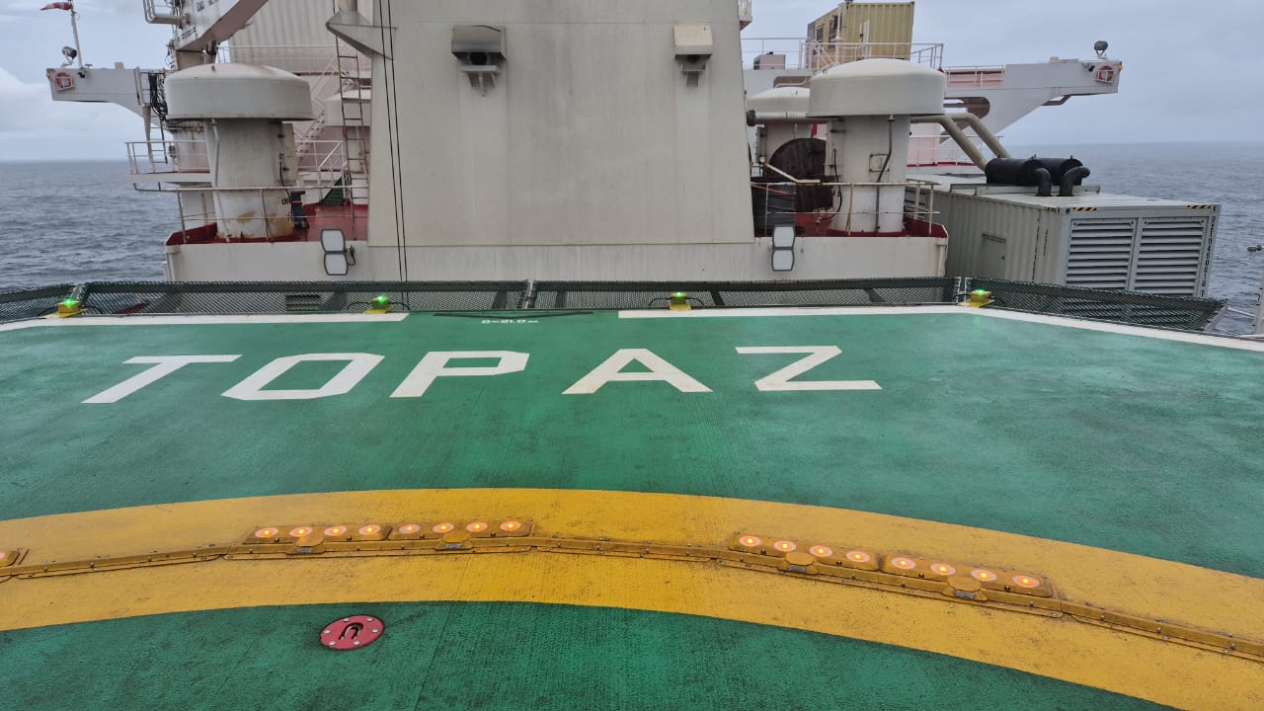
LANDING SITE INSPECTION REPORT
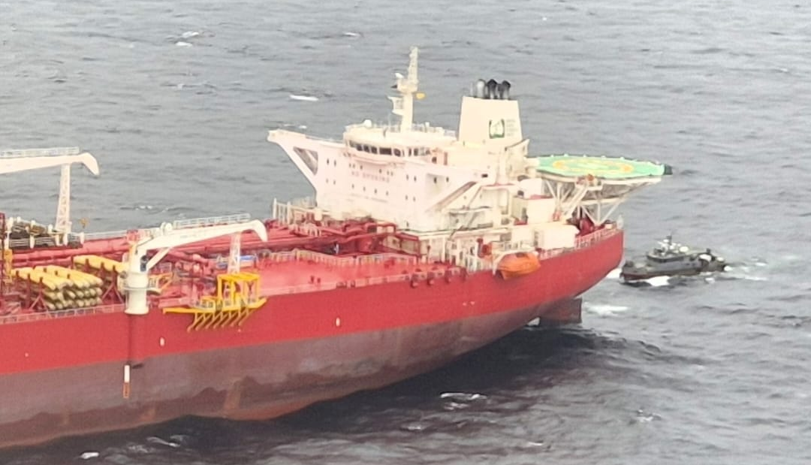

Installation/Vessel Name | FSO TOPAZ
Owner/Operator | ORIENTAL
Inspector | OLISA KENECHUKWU
Operational Clearance (Day/Night) | DAY  NIGHT (MEDIVAC ONLY)
D Value & T Value | D VALUE: 21M, T VALUE: 12.8T
Date of Previous Inspection | NIL
Date of Current Inspection | 27TH July 2026
Date of Next Inspection  (Maximum 2 years – Manned locations)  (Maximum 2 years – NUI locations) | 26TH July 2028
Executive Summary:

Inspectors Executive Summary: I carried out a Helideck Inspection of the FSO TOPAZ on the 27th of July 2026. This inspection was conducted in accordance with the UK CAA CAP 437 and all other supporting documents. The Captain and HLO, were very instrumental during the inspection exercise and efforts are well appreciated.
The Helideck team showed a good level of competence in carrying out their duties. They don’t have an operational digitalized weather report system in place. The analogue weather systems were observed and are working. Also, there were no UPS power systems powering the importance systems as per CAP 437.
The HDA certificates were expired so recertification will be required, radio operator certificates were not sighted, I recommend that a UPS system be installed and an HMS system for weather be installed as well. Lastly their DGR manual was not sighted request for the manual has been made. Overall, it was a successful inspection, and the crew seemed to be willing to make these corrective adjustments.
And flight operations can commence at this helideck.

Inspector’s Executive Summary
VHF and HAND HELD RADIOS  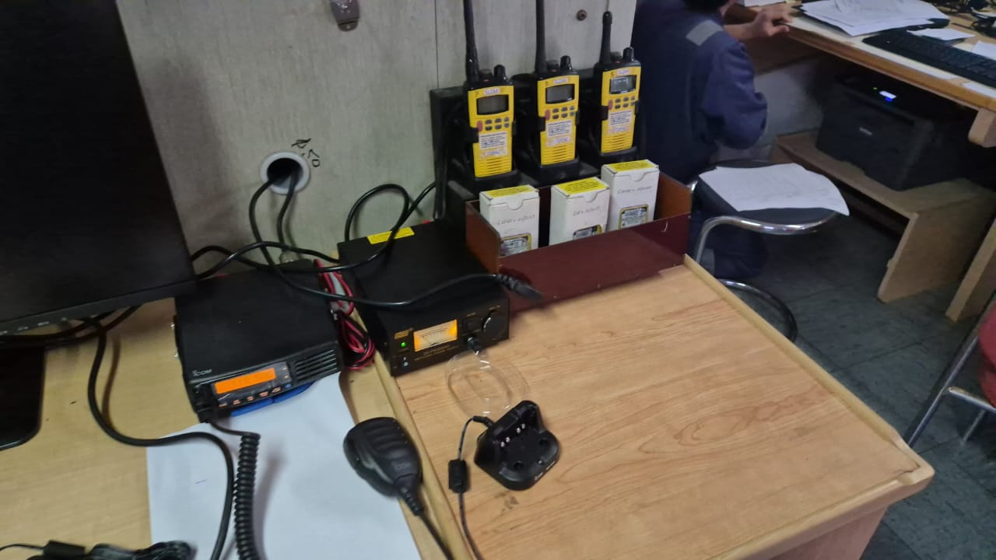 | CALIBRATED WEIGHING SCALE  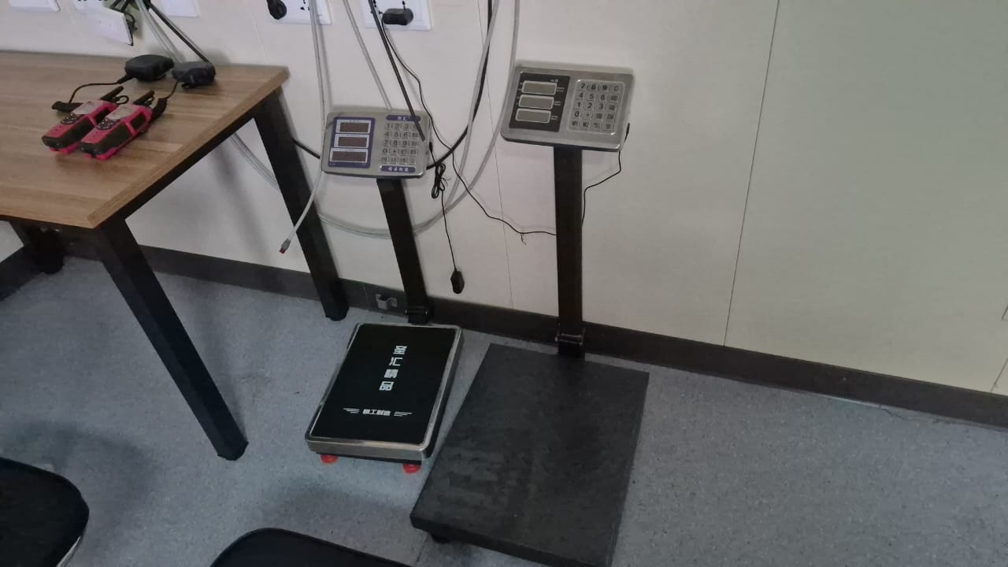
BRIEFING ROOM  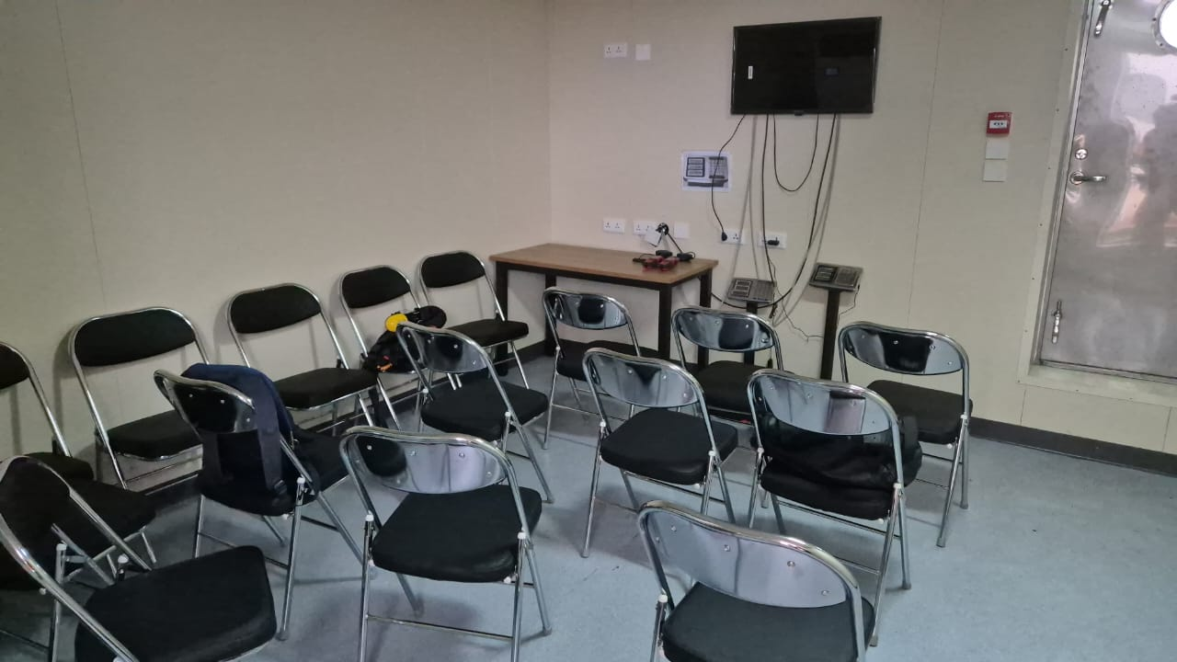 | WIND SOCK WITH ILLUMINTION  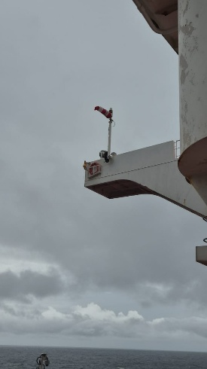
HELICOPTER CRASH BOX  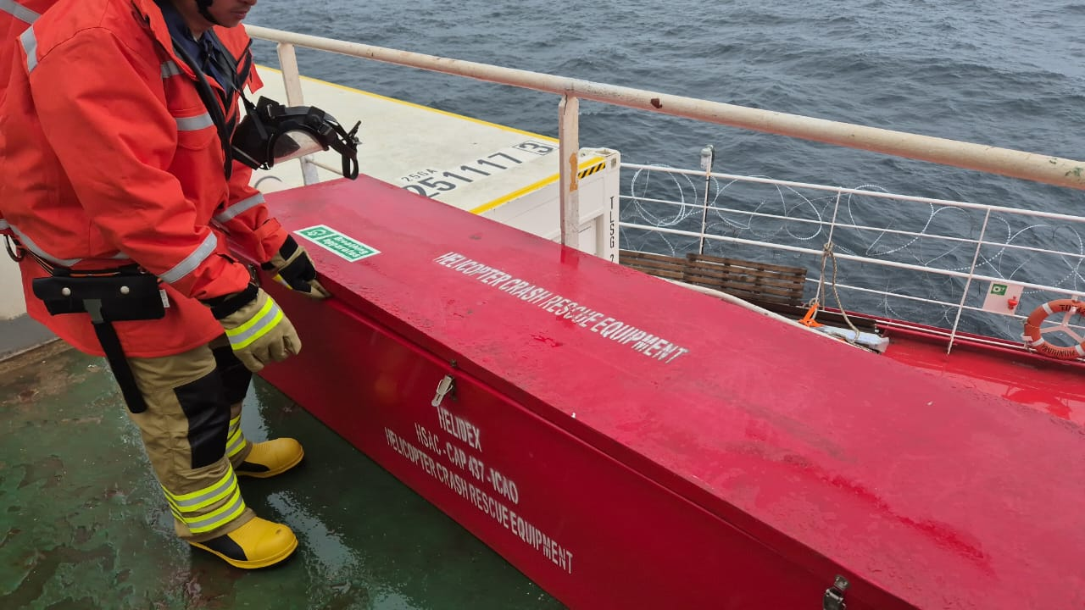 | ANEMOMETER AND INCLINOMETER  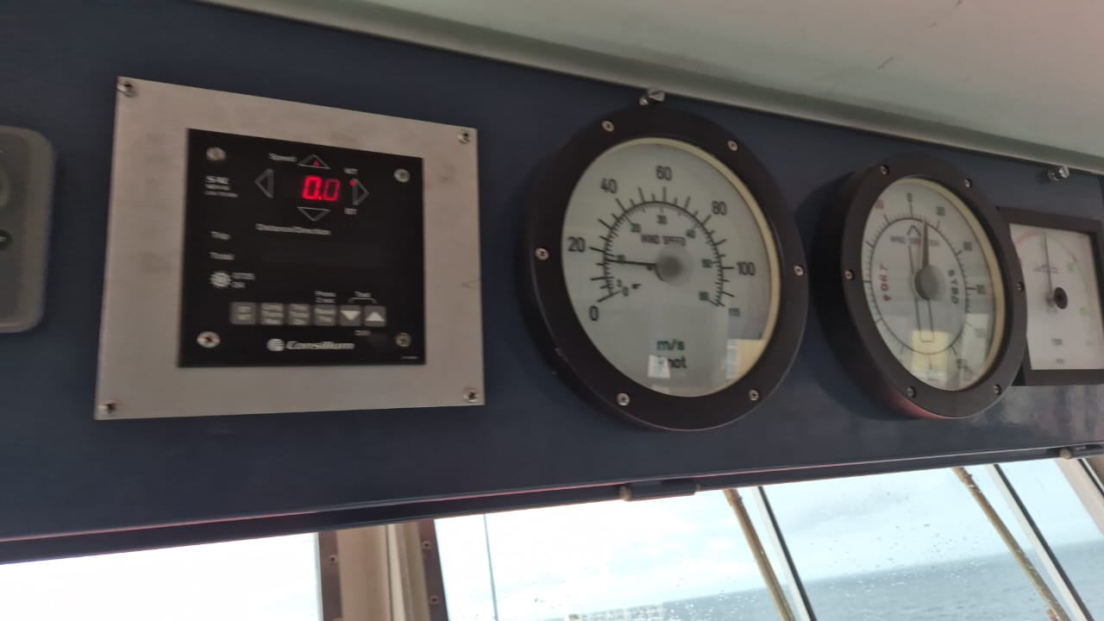
SEALED HELIDECK WITH AIR GAP  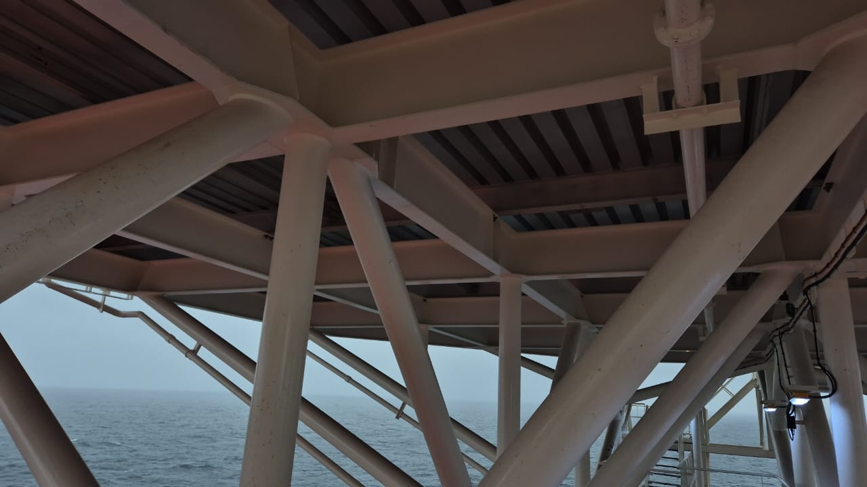 | LIFEBOAT  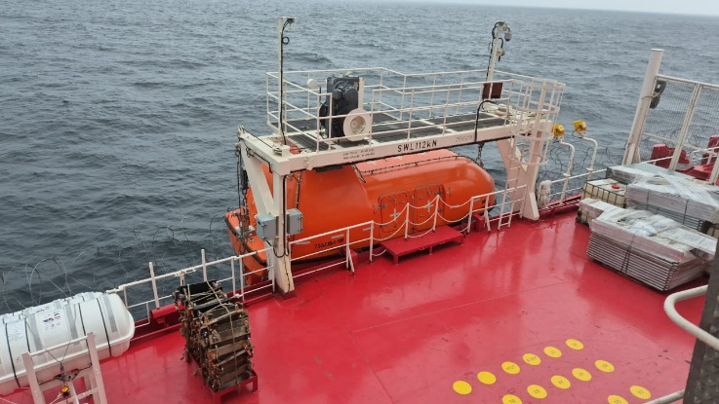
TOP VIEW  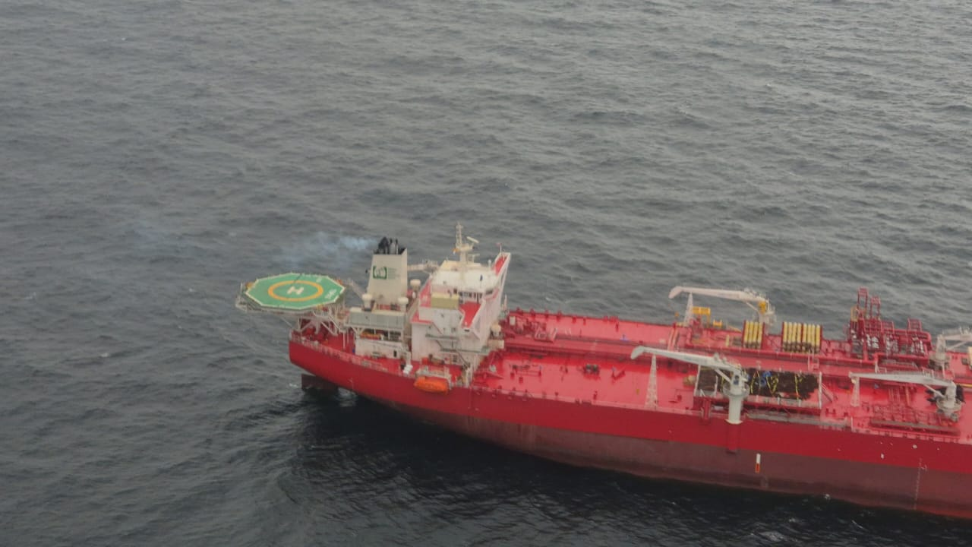 | AFFF FOAM AND WATER HOSE STATION  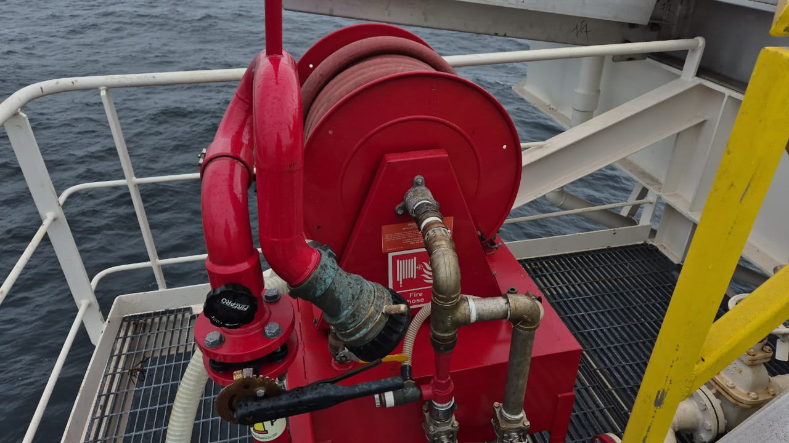
GOOD HELIDECK LIGHTING  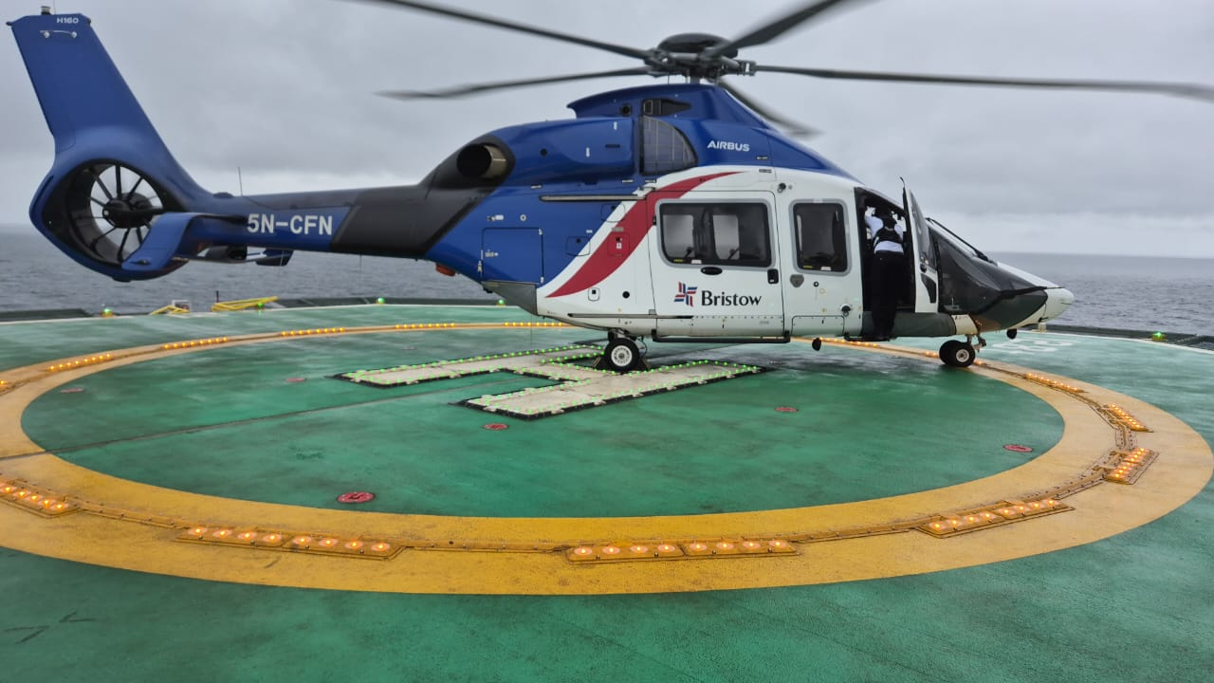 | PRIMETER SAFETY NET AND LIGHT  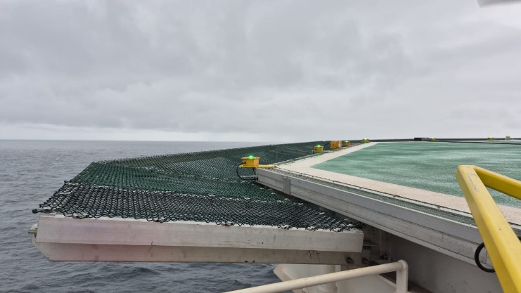

Non-conformances are classified as:
- High Priority Critical Actions (these actions must be addressed before air operations can commence)
- Medium Priority Actions (these actions may impact continued operations and restrictions may be imposed)
- Low Priority Actions (these actions may lead to operating restrictions and must be addressed before a full approval is given)

FORMAL LIST OF NON-COMPLIANCE
# | Non-Compliance | Action Party | Priority  (High/Med/Low) | Target Closure Date | Date  Closed | How was Closure Verified
1. | Dangerous goods Manual not sighted | Oriental | Low | 30.SEPT.2026
2. | Normal and Emergency procedures not sighted | Oriental | Med | 30.SEPT.2026
3. | Training manual | Oriental | Med | 30.SEPT.2026
4. | Chocks 1, 6 required | Oriental | Low | 30.SEPT.2026
5. | Prohibited landing marker not sighted | Oriental | Low | 30.SEPT2026
6. | Ladder not sighted | Oriental | Med | 30.SEPT.2026
7. | HLO identifier on waistcoat not compliant | Oriental | Low | 30.SEPT.2026
8. | Radio operator license not sighted | Oriental | Low | 30.SEPT.2026
9. | HDA Opito certificate expired | Oriental | Med | 30.SEPT.2026

Recommendations to improve the helideck procedures, equipment or best practice. Not mandatory

RECOMMENDATIONS

 | Recommendation | Action party | Priority |  | Date closed | Comments
1. | HELICOPTER SAFETY STICKERS SHOULD BE PLACED IN THE BRIEFING ROOM |  | LOW

HELIDECK LIMITATIONS LIST (HLL)
Aircraft Type | Limitation Imposed | Reason for Limitation | Date  Limitation  Effective | Date  Limitation  Removed | Reason Limitation Removed

LANDING SITE INSPECTION ENDORSEMENT

NAME of LANDING SITE

NAME of BASE

DATE OF INSPECTION
Helideck Inspector | Name: OLISA KENECHUKWU  Signature:  Date: 5TH September 2026
Pilot-in-Charge / Chief Pilot | Name:  Signature:  Date:
Head of Flight Operations | Name:  Signature:  Date:
Quality and Safety Manager | Name:  Signature:  Date:

Email Distribution List
- BHNL Pilots-in-Charge / Managing Pilots
- Head of Flight Operations
- Quality & Safety Manager
- Landing site coordinators
- Service delivery coordinator

